How to Join a Centre
- After logging into your CAMC account, click on My Profile.

- Then select My Membership.
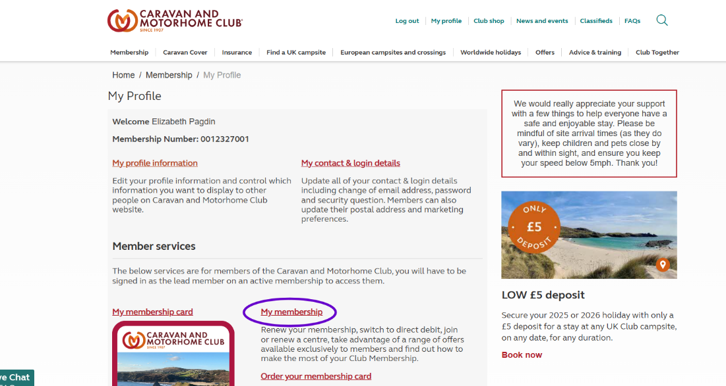
- Click on Join a Centre.
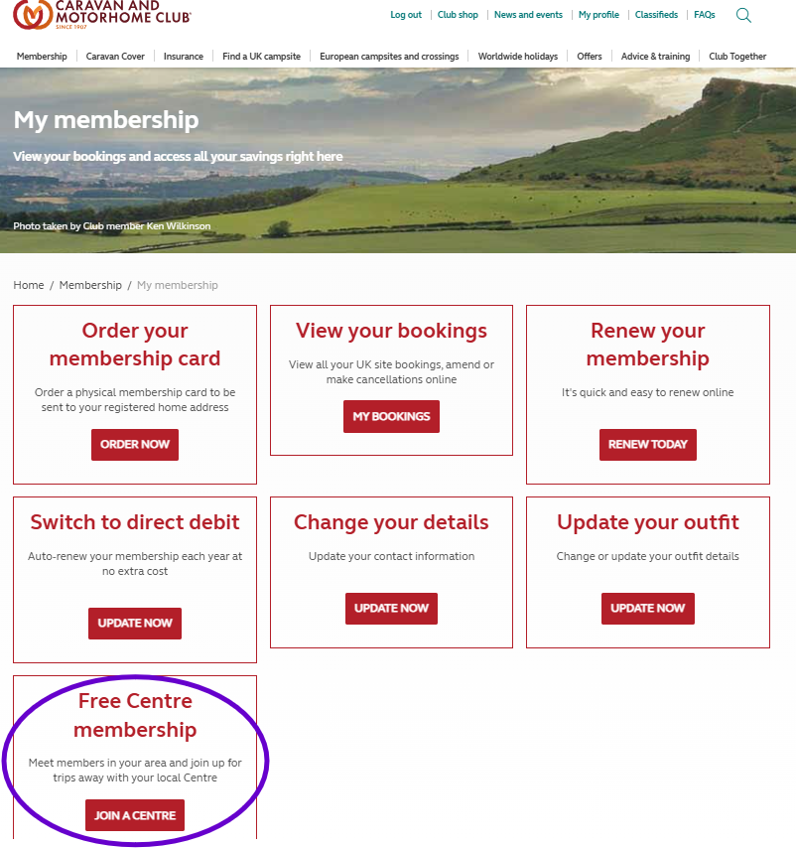
- Then select the Centre you wish to join.
- Remember to repeat this yearly as it will not renew automatically when your CAMC membership renews.

